***Revision Worksheet***

***Grade 3***

***Q1: Add the following.***

1. ***7859 + 6984 ii)6783 + 4003 + 6932***

***Q2: Subtract the following.***

1. ***7629 – 4872 ii)2589+5683-4983***

***Q3: Write in words.***

1. ***7032***
2. ***8506***

***-------------------------------------------------------------------------------------------------------------***

1. ***3999***

***-------------------------------------------------------------------------------------------------------------***

***Q4: Complete the following.***

1. ***4000 + 500 + 60 + 4 = -----------------***
2. ***----------- + 100 + 30 + 6 = 9136***
3. ***6000 + 900 + 700 + ------------ = 6971***
4. ***5000 + 500 + --------- + 5 = 5555***

***Q5: Ali has 5489 rupees. Asim has 6872 rupees. How many total rupees they both have altogether?***

***Q6: In a fruit basket there is a 456 apples. 389 less bananas then apples. How many apples and bananas are there altogether in a fruit basket?***

***Grade 1***

***Revision worksheet***

***Grade 1***

***Q: Add the following.***

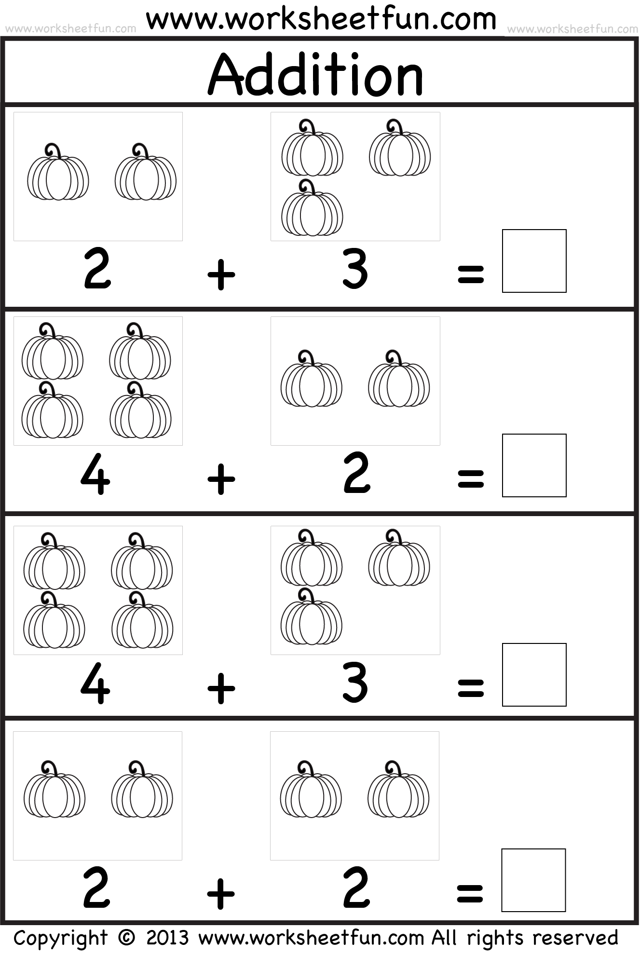

***Q: Complete the number bon***

